overview – Agreements
What is the Agreements module within the Student Information System?
The Agreements module is the system component that supports management of graduate research progress. It will be used to more efficiently manage the new graduate research induction checklist and progress reporting. This includes completing the new progress milestones: confirmation, mid-candidature review (for doctoral candidates) and pre-submission review as well as any ad-hoc progress reviews.
What is the role of the GRC within the Agreements module?
GRCs will use the Agreements module to:
- Ensure candidates’ Progress Committee Chairs and any additional independent members are entered on their induction checklist, sign off that they are appropriate and don’t have any conflicts of interest and then submit the checklist to the GRS
- Review progress reports for candidates placed at-risk, approve any requested postponement of the milestone date to allow for a second attempt at the milestone and then submit the report to the GRS
- Review the progress reports for candidates assessed as making unsatisfactory progress and add comments, before forwarding the report to the appropriate SGRC
This document will provide guidance on:
- Accessing a form requiring your input
- How to complete your sections of the form and submit it
Please review the policies via the link: http://www.latrobe.edu.au/grs/progress

Activity |  | SIS
Accessing a form requiring your input  1. When a form requires your input, a system generated email will be sent to you with instructions and a link to the form.  2. Scroll to the bottom of the email and click on the blue hyperlink labelled ‘click here’ to open the form in a web browser.  Access to specific forms is via specific links in the relevant email. Please retain the e-mail in case you want to access the form at a later date  Note: don’t use Firefox to view the form as it can cause problems when editing the form. |  | 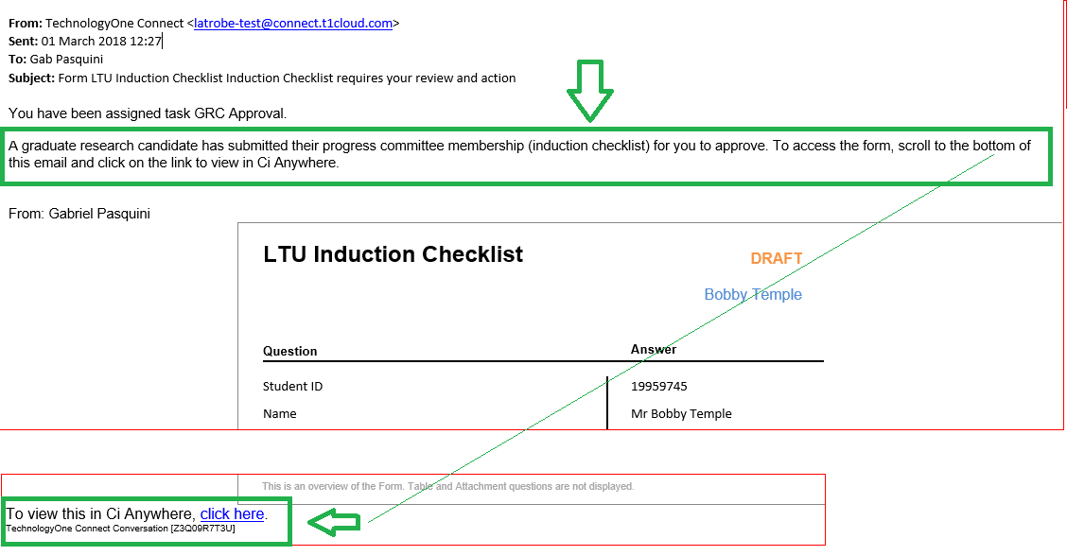
How to complete your part of the form    When the form first opens in your browser it will be in preview mode. Before reading and completing the form you need to open it in edit mode:  - 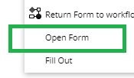Click on the menu button and select Open Form  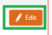  - Click on Edit  - Complete the relevant parts of the form  You can save  any changes you’ve made to a form and come back later to complete it via the link in the original e-mail. |  | 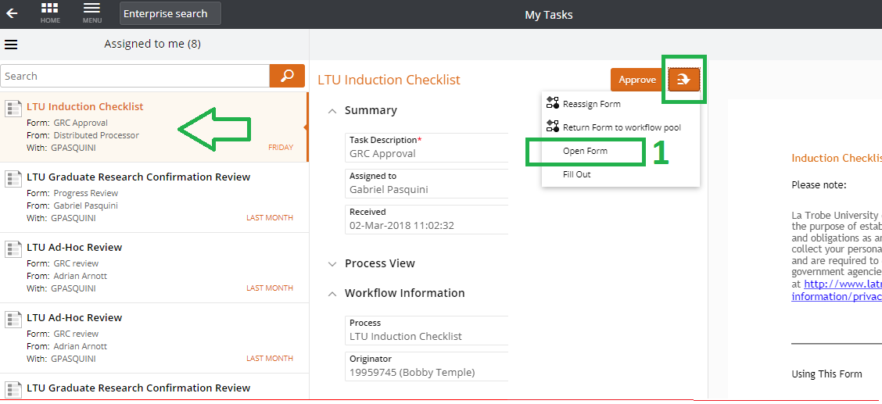  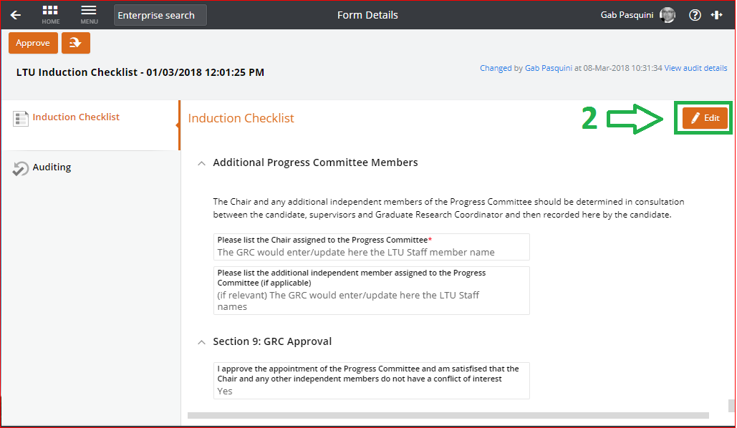
How to submit the form  Once you have reviewed and completed your sections of the form, you are ready to submit. Each form has a slightly different button for submission. When you click the button, if you haven’t saved your changes, you will be prompted to do so.  1. Induction checklist: click [Approve]. The system will automatically send the form to the GRS for final processing.  2. At-risk progress reviews: click [Submit]. The system will automatically send the form to the GRS for final processing.  3. Unsatisfactory progress reviews:  - Click on [Send to SGRC]. The system will produce a pop up box asking you to select the SGRC.  - Select the relevant SGRC from the drop down list by clicking on the small triangle in the bottom right hand corner of the box. You can start typing the name to narrow the options.  - Click [OK]. An email will be automatically sent to the SGRC to notify them the form requires their review.  Note: If you can’t find the appropriate SGRC in the drop down list please contact the GRS on 9479 3640. | 1. 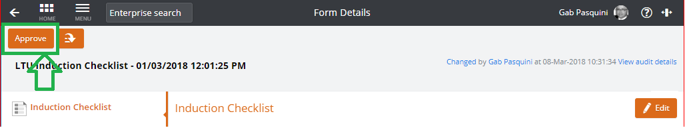  2. 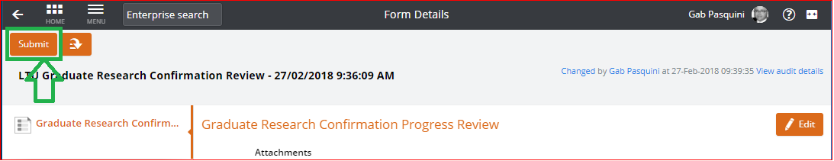  3. 