How to download a progress report: instructions for supervisors
Background:
This document provides guidance for supervisors on:
- Downloading a progress form and its attachments, eg in order to send a report to other progress committee members
There are 2 ways for supervisors to download a form:
- Using the download option when submitting the form – this won’t download any attachments
- Downloading the report and attachments as a zip file using My Academic – this can be done at any time
More information about the progress policy can be found on the GRS website: http://www.latrobe.edu.au/grs/progress
More information on using My Academic can be found on the My Academic LMS page.
Instructions:
Dowloading a form when submitting it
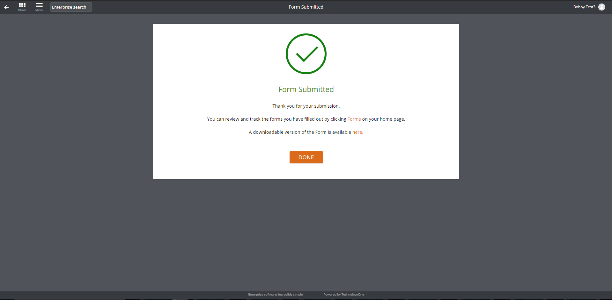
- When you submit your supervisor’s report, the confirmation pop up box includes a link to click on to download the form. This will save a pdf of the report itself but will not include any files that were attached to the report

Dowloading a form via My Academic
- Log into My Academic
- Select the My Academic workplace (1) and then click on the Students tile (2)

- Search for the relevant student by entering the student’s name in the search bar as GivenName%FamilyName or by entering their Student ID and clicking on the magnifying glass
Any results matching the input criteria will appear in a list below the search field:

TIPS:
- The % symbol acts as a wildcard, so if you search for ‘stu%dent’, the search will return any students who have ‘stu’ and ‘dent’ in their name. If you don’t use the % sign (ie ‘Stu Dent’) the search will only return students whose full name matches this search precisely – ie students with no middle name.
- If the student you are searching for doesn’t appear, try clearing the filter that is applied automatically by clicking on the filter icon (1) and selecting ‘clear all’ (2):
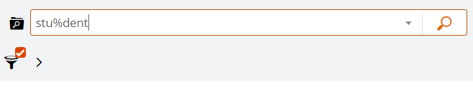
(1)
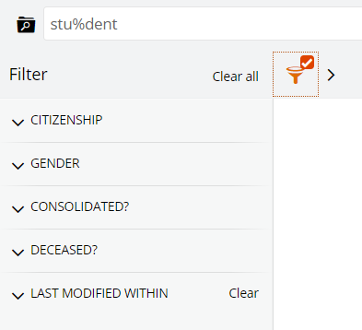
(2)

- If your student still doesn’t appear and you were searching by name, try searching by student ID number

- Once you have found the student you are looking for, click on the ‘View’  button to open the student’s record:
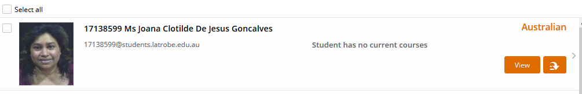

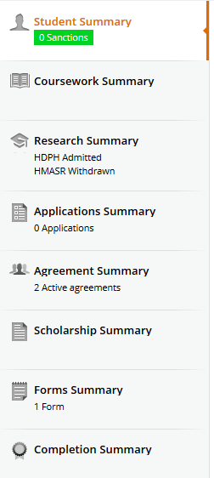
- Click on the ‘Forms Summary’ tab on the left-hand side of the screen to see a list of all forms (reports) which have been created for that student. This will include any completed reports as well as any that are in progress.

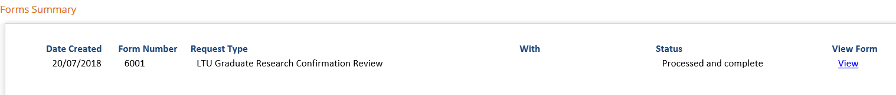
- Click the ‘View’ link next to the form to open the form

- Click on the options  button up the top (1) and select ‘download’ (2)
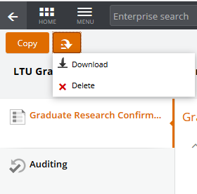
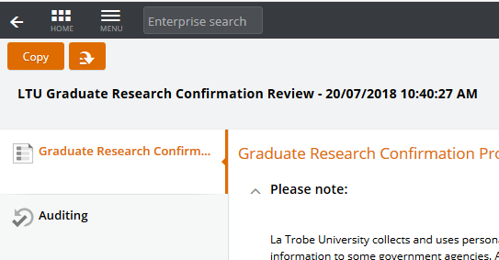
(2)
(1)

