

Ethics, Integrity and Biosafety
Research Office

Department of Agriculture, Fisheries and Forestry (DAFF) Approved Arrangement Facility Audits
From: Approved Arrangements General Policies Version 7.3: Approved Arrangements Program Compliance and Enforcement Division
Audit Types
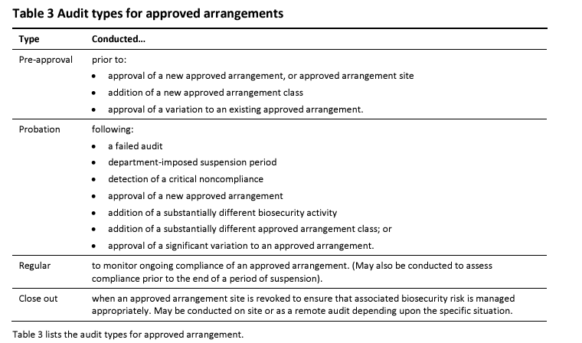
AUDIT rates
Biosecurity industry participants that are newly approved or demonstrate poor compliance are audited more frequently than those which have a demonstrated history of good compliance.
Probationary Audit Rate
Where an approved arrangement has had a variation approved for the biosecurity activities carried out, it may be subjected to the probationary audit rate if the new biosecurity activity is significantly different to the biosecurity activities already being carried out.
- When subject to the probation rate, at least two probation audits will be conducted on any business day within the 180-day probation period.

Low Audit Rate
The low audit rate recognises and rewards the biosecurity industry participant’s good history of compliance with departmental requirements by reducing the regulatory intervention. It is the lowest level of regulatory intervention for biosecurity industry participants.
If the biosecurity industry participant fails an audit or a critical noncompliance is identified whilst at the low audit rate, the biosecurity industry participant will be placed on the probation audit rate.
- When on the low audit rate, at least one regular audit will be conducted on any business day within any 365-day period.
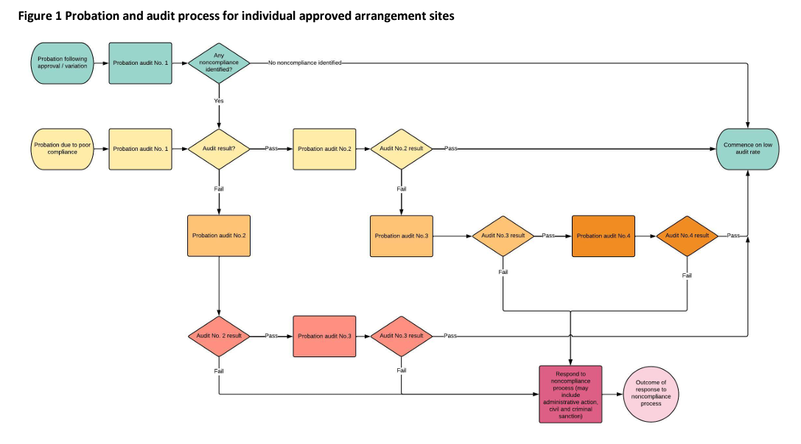

Noncompliance classifications

One or more critical instances of noncompliance will result in a:
- failed audit (if detected at audit), and
- probation audit rate.

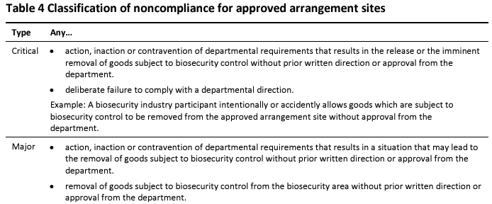
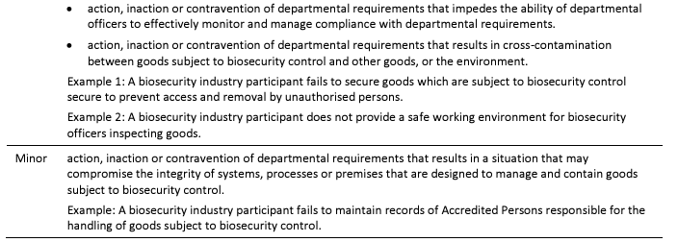
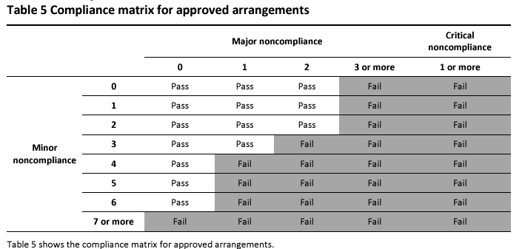
audit process
Fees
- On site: $62/15min
- Off site: $37/15min
Audit Report Actions
- You will have 2 business days from the date of the audit to provide any documents requested at the audit
- Critical non-compliance
  - 5 business days to rectify
- Major non-compliance
  - 10 business days to rectify
- Minor non-compliance
  - 28 business days to rectify
Notice of rectification of the non-compliance should be sent directly to the auditor via the biosafety team (not the general aa.canberra email).
Key Arrangement Outcomes (KAO)
Key arrangement outcomes are high level groupings of conditions. Each class condition for an approved arrangement is assigned a key arrangement outcome.
Containment: Goods subject to biosecurity control are contained in a way that prevents them, or any biosecurity risk material escaping into the environment.
Isolation: Goods subject to biosecurity control are isolated from other goods in a manner that prevents cross-contamination or cross-infestation.
Security: Controls are in place that prevent unauthorised access to goods subject to biosecurity control.
Identification: Goods subject to biosecurity control and areas in which biosecurity activities are carried out must be visually identifiable as such.
Traceability: Goods that are or were, subject to biosecurity control, are linked to records of the origin and movement of the goods and the biosecurity activities carried out in relation to the goods.
Hygiene: Approved arrangement sites are maintained in a state that minimises opportunity for, and susceptibility to pest, weed and disease establishment and/or infestation.
Movement: Goods subject to biosecurity control only move beyond the site in accordance with departmental conditions and any required departmental authorisation.
Release: Goods and their derivatives subject to biosecurity control are dealt with as such until they are formally released from biosecurity control, or they are exported or destroyed.
Awareness: People performing biosecurity activities involving goods subject to biosecurity control have the knowledge and capability to carry out those activities in accordance with the conditions of the approved arrangement.
Inspection: The site has the equipment, facilities and processes that enable inspection of goods subject to biosecurity control.
Treatment: The biosecurity industry participant has the processes and/or equipment and facilities to perform treatments of goods subject to biosecurity control in accordance with the conditions of the approved arrangement.
Arrangement compliance: The biosecurity industry participant is required to carry out biosecurity activities in accordance with the approved arrangement.
Notification: The department is advised of any event or circumstance for which it has specified that notification must be provided.
Supporting functions: Procedures, facilities and equipment are in place for the biosecurity activities carried out under the approved arrangement.
Checklist – audit requirements
From: Approved arrangement: Biosecurity containment level 2 (BC2) Conditions Version 1.0
Type of goods and work classified Microbiological BC2 (Microbiological Class 5.2) may include:

a) soil and water samples for microbial or viral isolation
b) cultures of microorganisms
c) animal samples such as fluid, tissues, and swabs
d) biological material for in vivo work in animals
e) animal blood/tissue known or suspected to be infected with exotic pathogens (containment level assessed by the department on a case-by-case basis taking into account species, country of origin, and the pathogen/s concerned)
f) tissue cultures (for example, live plant material kept in sealed tubes, Petri dishes or similar sealed devices)
g) plant growth in sealed cabinets (chambers or rooms with seals on doors to BC2 standard)
h) handling positive controls such as infected plant material or plant pathogens
i) diagnostics such as PCR (Polymerase Chain Reaction) PCR, (Enzyme Linked Immunosorbent Assay) ELISA, or (Electron Microscopy) EM
j) seed testing (for example, where seeds are not germinated or where seeds are milled by grinding, crushing, threshing).
Audit Responses and Documentation Needed for BC2 (Microbiological Class 5.2) Facility Audit
Note: This checklist is not exhaustive. Refer to the BC2 Conditions document for all conditions applied to an Approved Arrangement.
- Containment/Isolation/Security/Identification
☐ Printed site map (A3) available for auditor to view (2.1.5)
- All site maps must be endorsed by DAFF i.e the map sent to DAFF in the application will have been sent back as an endorsed copy.
- All changes (with version controls) to the site map must have been sent to AA.Canberra@aff.gov.au within 15 days of the change for re-endorsement.
- If new waste treatment or biosecurity goods handling equipment identified on the site map, need to contact AA.Canberra@aff.gov.au within 15 days to get an administrative variation that will result in an audit of said equipment and locations.
- If there are planned works to the facility, need to notify a AA.Canberra@aff.gov.au to suspend all or part of the AA area.
☐ Clear signage indicating level of containment prominently displayed at (2.1.8):
- Entry to the AA
- Entry to a biosecurity storage area located outside of the AA
☐ Annual inspection records confirming
- limited and secure access to the facility (1.1.13; 2.9.1)
  - Must be able to describe how swipe card access to the site is granted only to approved persons
- checks to self-latching of facility boundary doors (1.1.13; 2.1.19)
- checks for inwards airflow using smoke pencil or tissue at the gaps in a closed doorway (1.1.12; 1.1.13)
☐ Waste storage protocols stating the following waste storage conditions:
- 21 days (ambient): Non-perishable waste (7.17.1a)
- 48 hours (ambient): Perishable waste (7.17.1b)
- 90 days (4°C): Plant and leaf litter including stems, flowers and pruning’s) (bagged and stored in lidded bin) (7.17.1c)
- Up to 12 months at ≤4°C if waste cannot be treated or collected according to the above timeframes (7.17.4)
  - All waste to be treated or disposed of within 48 hours of removal from cold storage (7.17.3)
- ≤4°C waste storage must have daily temperature logging and over temperature alarm installed (7.17.2)
- All waste holding enclosures labelled as ‘Biosecurity Waste’ or ‘Biosecurity Waste Storage’ (2.6.5)
☐ Show an (version controlled) organisational structure chart/list of all personnel with access to the facility (1.1.2; 2.1.6)
- Must be version controlled based on staff changes etc.
- Clearly identify on the chart, persons responsible for:
  - controlling, directing, enforcing or monitoring people performing activities associated with the approved arrangement.
    - approved arrangement manager
    - approved arrangement contact person(s) for the approved arrangement site
    - approved arrangement accredited/ authorised person(s) for the approved arrangement site.
  - Notice of change to responsible persons must have been sent to AA.Canberra@aff.gov.au within 15 days.
  - Chat can have a generic “students” section
☐ LTU LMS BBAT (and if applicable Agriculture Victoria Biosecurity Awareness) training for all personnel approved to use the facility should be accessible during the audit.
☐ Procedures/protocols for segregation of goods subject to biosecurity controls stating that:
- Multiple consignments of plants subject to biosecurity control must be segregated (unless approved by the department in an import permit allowing the crossing of consignments) (11.3.2)
- Separate consignments of imported animals must be kept physically segregated until an initial health check/examination has confirmed that the animal or animals are in good health (14.4.2 to 14.4.4)
- A containment cabinet or other primary containment device or equipment must not be used simultaneously with goods subject to biosecurity control and goods not subject to biosecurity control, unless the relevant goods not subject to biosecurity control are subsequently treated as goods subject to biosecurity control (4.1.4)
  - This condition does not apply to a microbiology laboratory where goods subject to biosecurity control may be segregated using dedicated work areas provided this method is effective and there is a very low risk of goods subject to biosecurity control being dispersed beyond the work area
☐ PPE Storage is (2.2.1):
- within the approved arrangement site, near the exit, and at access points to toilet facilities within the containment boundary, or
- where there is animal or aquatic primary containment within the anteroom
☐ Minimum PPE includes (4.7.1):
- gown or laboratory coat or overalls/coveralls
- gloves
- closed footwear (footwear which covers the toes and heels)
☐ PPE treatment post use includes (4.7.2):
- disposable personal protective equipment (for example, gloves)
  - must be disposed of as biosecurity waste
- reusable non-contaminated personal protective equipment must:
  - be retained in the approved arrangement site between uses
  - be segregated from unused personal protective equipment
  - be laundered at least every 3 months (clothing), unless protected from contamination by suitable storage or packaging
- reusable contaminated personal protective equipment must be:
  - placed in dedicated containers for disposal or treatment when cannot be immediately cleaned (4.7.3)
  - where laundered on-site, cleaned with department approved disinfectants (for example, for eye and face protection and footwear)
    - standard laundry detergent may be used
  - where laundered off-site, steam sterilised first or
  - disposed of via a department approved method

- Awareness
☐ Personnel must be able to demonstrate conditions and risks relating to goods subject to biosecurity control:
- Understanding of department conditions relating to their duties e.g. import permit conditions, BICON, AA site conditions (5.1.1) including:
  - the specific permit conditions for the biosecurity goods
    - release conditions (6.4, 7.1.1; 7.1.3)
    - post entry conditions (6.5, 8.2)
    - treatments (2.6, 4.1 to 4.7, 7.1 to 7.17)
  - appropriate storage areas and storage conditions including levels of access (2.6,7.17, 8.8)
  - transport requirements including record keeping and containment (6.1, 6.6 to 6.8)
- Understanding of biosecurity risks in relation to their duties and protocols to address the risks (5.1.2)
- Ability to differentiate between goods subject to biosecurity controls and goods not subject to biosecurity control (5.1.3)
- Tractability and Movement of Biosecurity Goods
☐ SOP or guide stating that records must be retained for all goods subject to biosecurity control for a minimum of 24 months from the date of being treated or released (8.2.1)
- Must be able to demonstrate that all personnel understand this requirement
☐ Records of all activities related to biosecurity control, including records of (8.2.3):
- current holding of goods subject to biosecurity control identified by:
  - scientific name (and, where identified, or used, the common name)
- receipt and holding which includes
  - date of arrival
  - type (for example, species, plant scientific names)
  - total quantities (for example, kilograms, litres, numbers) of goods subject to biosecurity received
    - Approximate numbers or quantities will be acceptable where it is impractical to determine precise measures e.g. 1 bag approx. 100 seeds, 1 bag approximately 1 kg.
    - Quantities must be updated immediately on usage or disposal
- location or part of approved arrangement site (for example, storage unit, animal house, plant greenhouse) where each item subject to biosecurity control is held/grown
  - Location must be updated immediately on transfer to another AA site or disposal
- department Import Permit or Import Permit number and commodity relevant conditions
- department biosecurity directions (for example, entry and release directions)
- country of origin
- any direct or indirect derivatives, (inclusive of breeding) from the original goods subject to biosecurity control (8.2.4)
☐ Records of movement and usage of biosecurity goods (Co-located: Multiple approved arrangement sites operating within a single physical site and sharing a common Australian Business Number (ABN) and an approved arrangement manager).
- Between non co-located AA sites (8.3.1):
  - AA approval number (forwarded to or received from) i.e. V#
  - Type classification i.e. Microbiological (Class 5.2.1)
  - Containment level i.e. Biosecurity Containment Level 2
  - Date of movement
  - Copy of biosecurity direction or direction number and/or Import Permit or Import Permit number and commodity relevant conditions
  - Type of good subject to biosecurity control (species/description for example, soil, water)
  - Total quantities (for example, kilograms, litres), or total numbers
  - Notification of acceptance from the receiving approved arrangement site
  - Acknowledgement of the return of goods subject to biosecurity control when not accepted by the receiving site
- Between co-located AA sites (8.3.2):
  - Name and type of approved arrangement site (forwarded to or received from)
  - Containment level
  - Date of movement
  - Import Permit or Import Permit number and commodity relevant conditions
  - Type of good subject to biosecurity control (species/description for example, soil, water)
  - Total quantities (for example, kilograms, litres) or total numbers
- Waste pickup records (8.3.3):
  - quantity/volume/weight
  - date and time of pickup
  - waste collection company name
  - vehicle registration number
  - destination (for treatment/disposal)
  - confirmation driver is aware waste is biosecurity waste, and
  - name and signature of driver undertaking pickup of biosecurity waste
- Treatment processes/equipment
☐ Steriliser calibration records (8.4.2.3):
- Dry/moist heat steriliser (autoclave)
  - Certificate of calibration
  - Temperature gauge/sensor calibration
    - Type of senor
    - Number of sensors
    - Location of sensors
- Validation test record of load profiles (4.2.2.4)
  - equipment used e.g. specific type of steriliser (make and model), data logger and probes including model and calibration certificate numbers
  - time and temperature of each probe throughout the test process
  - type of load validated and how the load was packed
  - cycle description (for example, time, temperature, downward displacement, pre-vacuum)
  - test results for example, lethality indicator assessment, time target temperature was reached, sterilisation end time, time sterilisation
  - temperature achieved for, and minimum temperature during the cycle
  - the date the validation test was performed
☐ Steriliser usage records (8.4.2.1):
- Cycle monitoring (autoclave)
  - Temperature and duration showing minimum of:
    - 15 minutes at 121°C or
    - 3 minutes at 134°C
- Lethality monitoring
- Cycles using a load profile (8.4.2.2) if applicable
  - Type of load
  - Specifications of load profile used
☐ On-site treatment records (8.4.1)
- traceability information of the contents of each load for goods subject to biosecurity control via permits directions
- the treatment used
- any processing problems/malfunctions
  - times and durations of malfunctions
  - a description of the malfunction
  - the corrective action taken
- dates of the above.
☐ Waste storage records
- Ambient storage (8.8.1)
  - duration of storage (e.g. date in and out)
  - the nature/type of waste
  - approximate quantity – in volume, weight or total number.
- Cold storage (≤4°C) (8.8.2)
  - monitoring (e.g. time and temperature) unless the cold room, refrigerator or freezer has an over-temperature alarm
    - daily intervals or less
  - duration of storage (e.g. date in and out)
  - the nature/type of waste
  - quantity – in volume, weight or total number
☐ Containment cabinet records
- Test report for laminar flow cytotoxic and Class I or II biosafety cabinets including (8.9.1):
  - model and date of test
  - HEPA filter installation integrity (aerosol penetration for Class I, II and cytotoxic)
  - inward air/face velocity (Class I)
  - air velocity and uniformity in works zone (Class II and cytotoxic)
  - work zone integrity (Class II and cytotoxic), and
  - containment at the aperture (Class ll and cytotoxic)
- Gaseous decontamination test reports (biological spore) including (7.13.1 to 7.13.8; 8.9.2):
  - test date and time
  - cabinet identifier
  - pass/fail results of individual spore strips identifying their locations (include test and control indicators)
  - biological indicators batch number
    - Control indicators are not required for every biological safety cabinet within a room, or where the same type (make and model) of cabinet is used in multiple approved arrangement sites within the one physical site
- Fume hood test records including (8.10.1):
  - a current test certificate (certifying acceptable annual testing)
  - a current compliance test report which at a minimum includes
    - date of test
    - model name/number
    - face velocity test results
☐ Pest control records (3.2.1; 8.11.1)
- the inspection regime and its frequency
- incident control measures used, if pest activity is suspected, or identified
- where applicable the contractors name and address
☐ Backflow Prevention Reports (RPZD) (2.5.2; 4.1.14)
- Testing of an RPZD must occur after installation, maintenance or repair, and thereafter at 12 month intervals
- Test reports to contain details of
  - the device (serial numbers)
  - location
  - building address
  - the test results
  - date of test

- Notification and contingency plans
☐ Procedures showing notification and response requirements including:
- Notification within 15 business days to AA.Canberra@aff.gov.au of:
  - Pest outbreak
  - Major spills that take longer than 15min to clean
  - Other – see conditions document
  - Small cracks are NOT notifiable
- If unknown import received
  - Notify within 5 business days to the imports email
☐ Records kept before/after site works (8.12)
- Before works
  - disinfection of surfaces and equipment, including
    - date applied
    - the department approved chemical used
  - functional verification(s), and/or calibration(s) of new equipment installed including
    - process
    - date
    - outcomes
- After works and before recommencement of work with goods subject to biosecurity control
  - written confirmation to the department from the construction/project manager, or contractor(s) that works have been completed
  - where required by the department, a third-party assessor report
references
Approved Arrangements General Policies Version 7.3 Approved Arrangements Program Compliance and Enforcement Division
Approved arrangement: Biosecurity containment level 2 (BC2) Conditions Version 1.0
Approved arrangement 5.2 – Biosecurity containment level 2 (BC2) Informative text Version 1.0
Approved Arrangements For 5.2—Biosecurity containment level 2 (BC2) Requirements—Version 3.0

Checklist – audit requirements (print)

- Containment/Isolation/Security/Identification
☐ Printed site map (A3) available for auditor to view (2.1.5)
☐ Clear signage indicating level of containment prominently displayed at (2.1.8)
☐ Annual inspection records confirming
☐ limited and secure access to the facility (1.1.13; 2.9.1)
☐ checks to self-latching of facility boundary doors (1.1.13; 2.1.19)
☐ checks for inwards airflow using smoke pencil or tissue at the gaps in a closed doorway (1.1.12; 1.1.13)
☐ Waste storage protocols stating the following waste storage conditions (2.6.5, 7.17)
☐ Show an (version controlled) organisational structure chart/list of all personnel with access to the facility (1.1.2; 2.1.6)
☐ LTU LMS BBAT (and if applicable Agriculture Victoria Biosecurity Awareness) training for all personnel approved to use the facility should be accessible during the audit.
☐ Procedures/protocols for segregation of goods subject to biosecurity controls stating that:
☐ Multiple consignments of plants subject to biosecurity control must be segregated (11.3.2)
☐ Separate consignments of imported animals must be kept physically segregated until an initial health check/examination has confirmed that the animal or animals are in good health (14.4.2 to 14.4.4)
☐ A containment cabinet or other primary containment device or equipment must not be used simultaneously with goods subject to biosecurity control and goods not subject to biosecurity control, unless the relevant goods not subject to biosecurity control are subsequently treated as goods subject to biosecurity control (4.1.4)
☐ PPE Storage is (2.2.1)
☐ Minimum PPE includes (4.7.1)
☐ PPE treatment post use includes (4.7.2)
- Awareness
☐ Personnel must be able to demonstrate conditions and risks relating to goods subject to biosecurity control:
- Understanding of department conditions relating to their duties e.g. import permit conditions, BICON, AA site conditions (5.1.1) including:
  - the specific permit conditions for the biosecurity goods
    - release conditions (6.4, 7.1.1; 7.1.3)
    - post entry conditions (6.5, 8.2)
    - treatments (2.6, 4.1 to 4.7, 7.1 to 7.17)
  - appropriate storage areas and storage conditions including levels of access (2.6,7.17, 8.8)
  - transport requirements including record keeping and containment (6.1, 6.6 to 6.8)
- Understanding of biosecurity risks in relation to their duties and protocols to address the risks (5.1.2)
- Ability to differentiate between goods subject to biosecurity controls and goods not subject to biosecurity control (5.1.3)
- Tractability and Movement of Biosecurity Goods
☐ SOP or guide stating that records must be retained for all goods subject to biosecurity control for a minimum of 24 months from the date of being treated or released (8.2.1)
☐ Records of all activities related to biosecurity control, including records of (8.2.3, 8.2.4)
☐ Records of movement and usage of biosecurity goods (Co-located: Multiple approved arrangement sites operating within a single physical site and sharing a common Australian Business Number (ABN) and an approved arrangement manager).
- Between non co-located AA sites (8.3.1):
- Between co-located AA sites (8.3.2):
- Waste pickup records (8.3.3):

- Treatment processes/equipment
☐ Steriliser calibration records (4.2.2.4, 8.4.2.3)
☐ Steriliser usage records (8.4.2.1, 8.4.2.2)
☐ On-site treatment records (8.4.1)
☐ Waste storage records (8.8.1, 8.8.2)
☐ Containment cabinet records (7.13.1 to 7.13.8; 8.9.1,8.9.2)
☐ Pest control records (3.2.1; 8.11.1)
☐ Backflow Prevention Reports (RPZD) (2.5.2; 4.1.14)

- Notification and contingency plans
☐ Procedures showing notification and response requirements including:
☐ Records kept before/after site works (8.12)

THIS PAGE IS BLANK

